**MODULE:1 (SDLC)**

**Q-1 What is software? What is software engineering?**

**Ans.** Software is a set of instructions,data or programs used to operate computers and execute specific tasks.

Software engineering is defined as a process of analyzing user requirements and then designing, building, and testing software application which will satisfy those require- ments.

**Q-2 Explain types of software.**

**Ans.** There are two main types of software are :

**1)system software:** it is a type of computer program that is designed to run a computer’s hardware and application programs.**e.g.,**windows as o.s in computer and android as o.s. in mobile

**2)Application software:** it is a type of computer program that performs a specific personal,educational,and business function.**e.g.,**amazon,flipkart,paytm,etc….

**Q-3 What is SDLC? Explain each phase of SDLC.**

**Ans.** It is a structured process that enables the production of high-quality,low-cost software , in the shortest possible production time.

Software development lifecycle (SDLC)

1)Requirements: A reasonable product delivery demands correct requiremnets gathering , the efficient examination of requirements gathered, and clear requirement documentation as a precondition

2)Analysis: The analysis phase also gathers business requirements and identifies any potential risks.

3)Designing: the design phase seeks to develop detailed specifications that emohasize the physical solution to the user’s information technology needs.

4)Development: It is to convert the system prototyped in the design phase into a working information system that addresses all documented system requirements.

5)Testing: The testing phase of the software development lifecycle (SDLC) is where you focus on investigation and discovery.

6)Deployment: the deplypoment phase in SDLC includes the work necessary to deploy the final solution into the target production environments.

7)Maintenance: The maintenance phase of the SDLC occurs after the product is in full operation.

**Q-4 what is DFD? Create a DFD diagram on fllipkart.**

**Ans.**

A data flow diagram is a graphical view of how data is processed in a system in terms of input and output.  
The Data flow diagram (DFD) contains some symbol for drawing the data flow diagram.

Data flow diagram symbol

|  |  |
| --- | --- |
| **Symbol** | **Description** |
| [dfd symbol](https://meeraacademy.com/wp-content/uploads/2016/09/arro.jpg) | **Data Flow** – Data flow are pipelines through the packets of information flow. |
| [dfd process](https://meeraacademy.com/wp-content/uploads/2016/09/process.jpg) | **Process :**A Process or task performed by the system. |
| [dfd entry symbol](https://meeraacademy.com/wp-content/uploads/2016/09/Entity.jpg) | **Entity :**Entity are object of the system. A source or destination data of a system. |
| [dfd source symbol](https://meeraacademy.com/wp-content/uploads/2016/09/source.jpg) | **Data Store :** A place where data to be stored. |

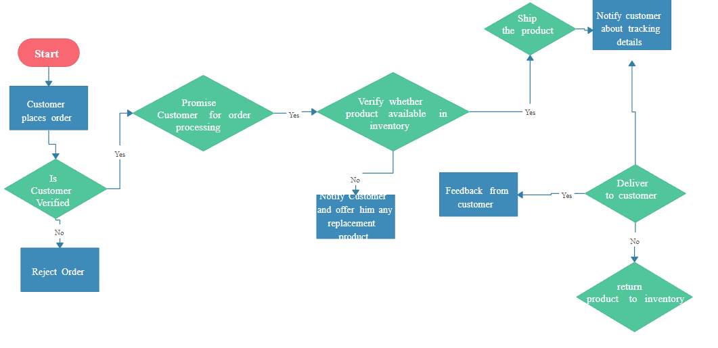

**5)What is Flow chart? Create a Flowchart to make addition of two numbers**

**Ans.**

**A flowchart**……is **a diagram that shows an overview of a program** . Flowcharts normally use standard symbols to represent the different types of instructions . These symbols are used to construct the flowchart and show the step-by-step solution to the problem. Flowcharts are sometimes known as flow diagrams.

Print sum

Declare variables no.1,no.2 and sum

Read no.1 and no.2

Add no.1,no.2 and assign value to sum

Sum=no.1 + no.2

**6) What is use case diagram? Create a use-case on bill payment of paytm.**

**Ans.**

A datagram is an independent, self-contained message sent over the network whose arrival, arrival time, and content are not guaranteed.

